

**Lab 4**

**CS 5-1 - BSCS – Operating System Lab**

**Name:** Sharaiz Ahmed **SAP:** 57288

# **Bandit-0**

Learn to connect via SSH and read a file to get the next password.

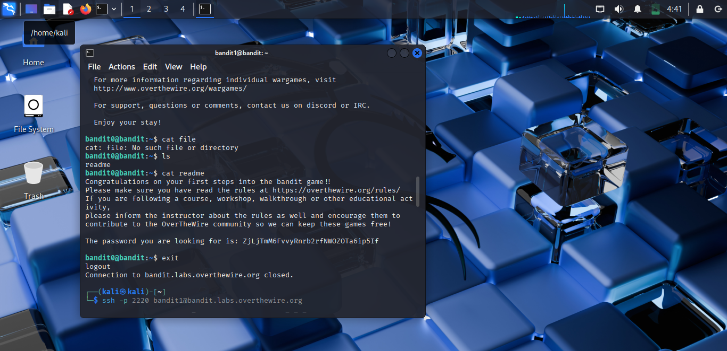

# **Bandit-1**

Handle files with tricky names (like -) using proper paths.

cat ./-

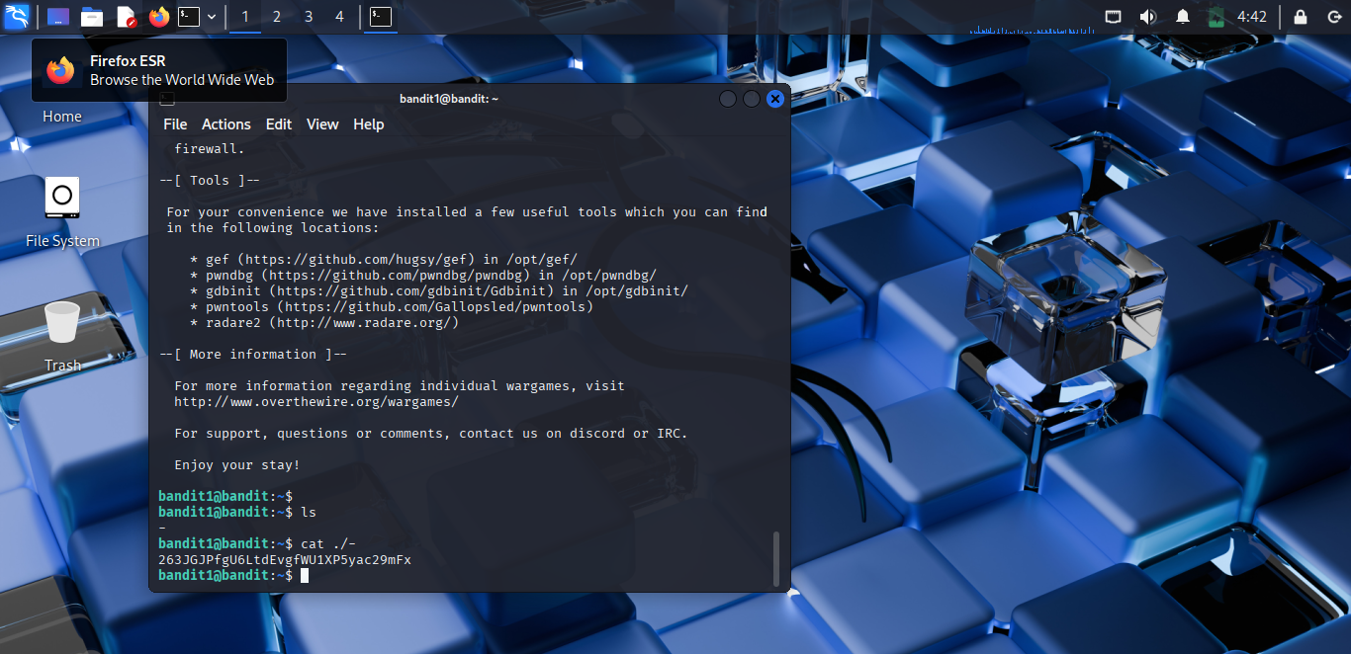

# **Bandit-2**

Open files with spaces or special characters in their names.

Cat “./--speces in this filename—"

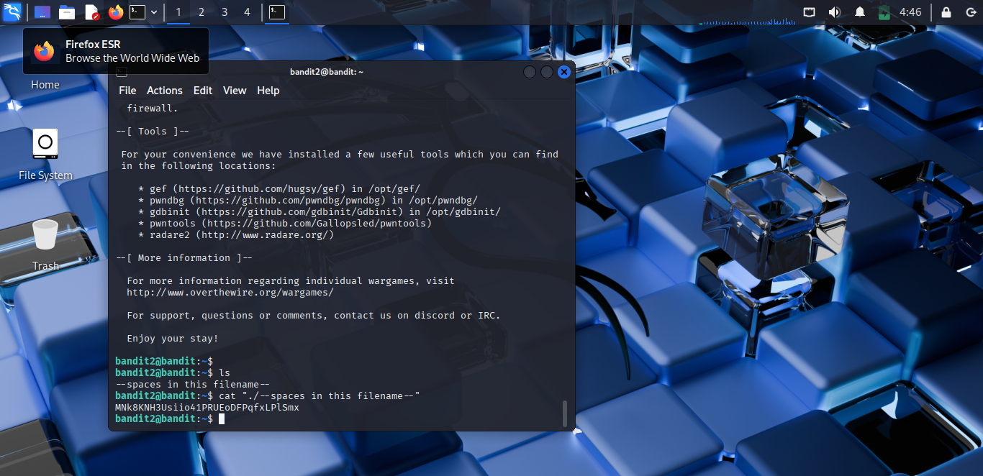

# **Bandit-3**

Discover and read hidden files in a directory.

Cd inhere

Cat …Hiding-From-You

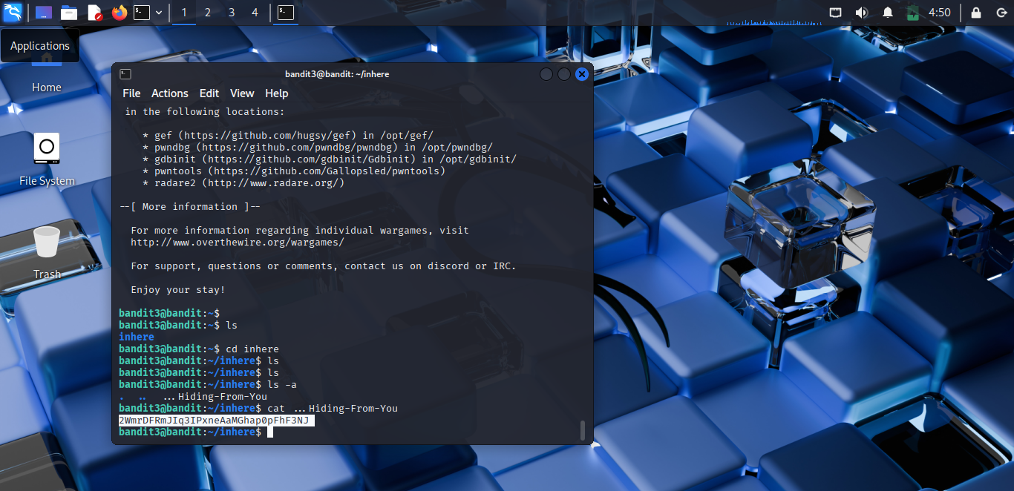

# **Bandit-4**

Search directories to find files with specific properties.

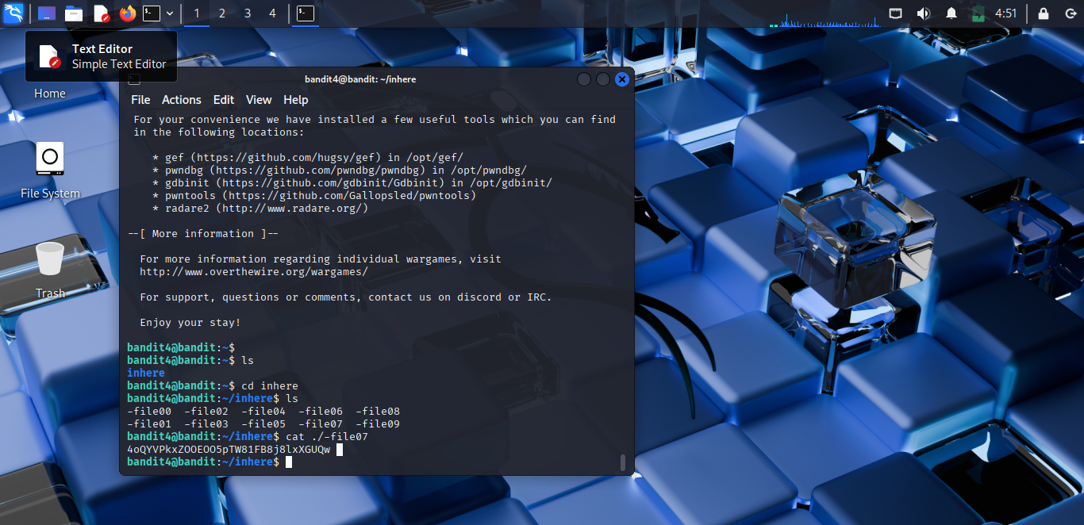

# **Bandit-5**

Use find to locate a non-executable file of exact size.

find . -type f -size 1033c ! -executable

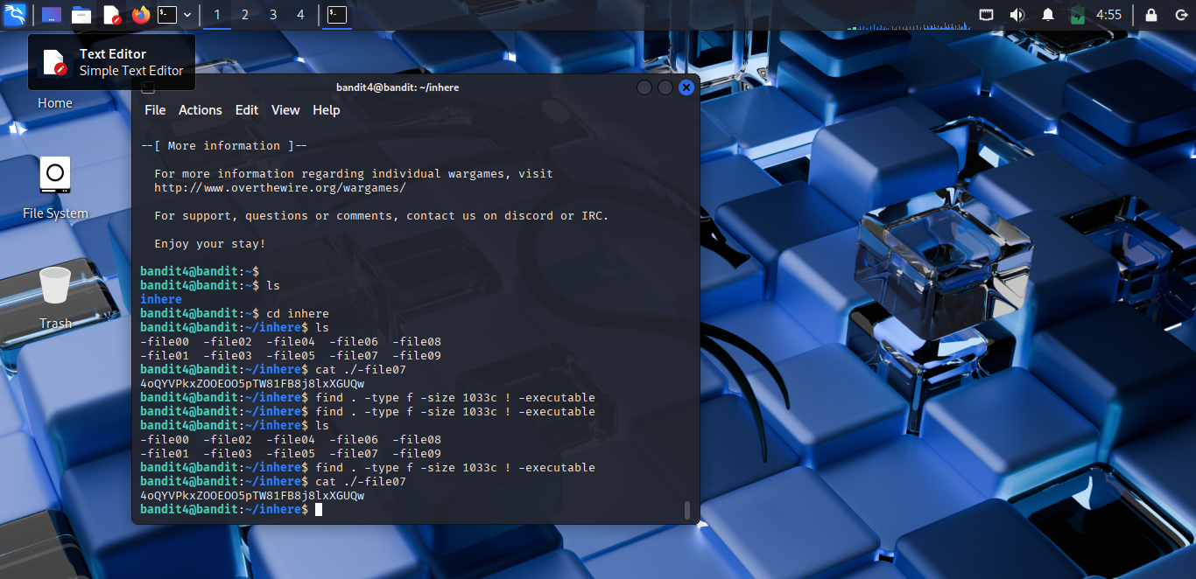

# **Bandit-6**

Find a file owned by a specific user and group with given size.

find . -type f -size 1033c ! -executable && cat file

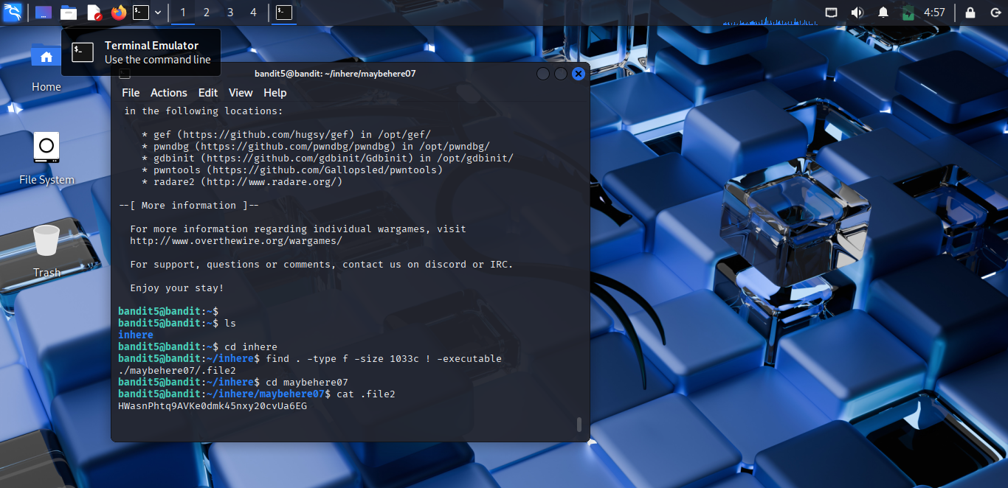

# **Bandit-7**

Find a file owned by a specific user and group with given size.

find / -user bandit7 -group bandit6 -size 33c 2>/dev/null

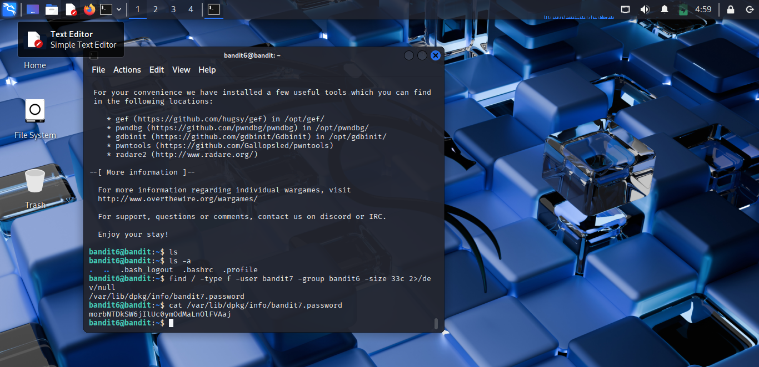

# **Bandit-8**

Search a text file for a line containing the keyword millionth.

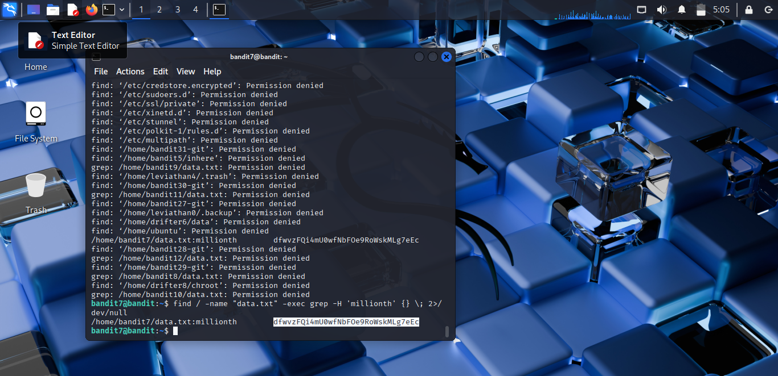

# **Bandit-9**

Identify the only unique line in a large text file.

sort data.txt | uniq -u

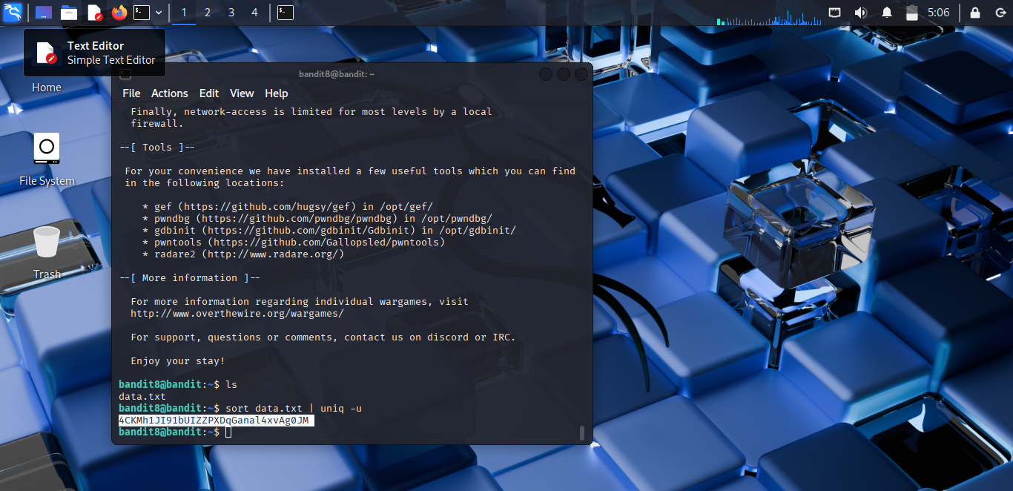

# **Bandit-10**

Extract human-readable strings from a binary file.

strings data.txt | grep -E '[A-Za-z0-9]{30,}'

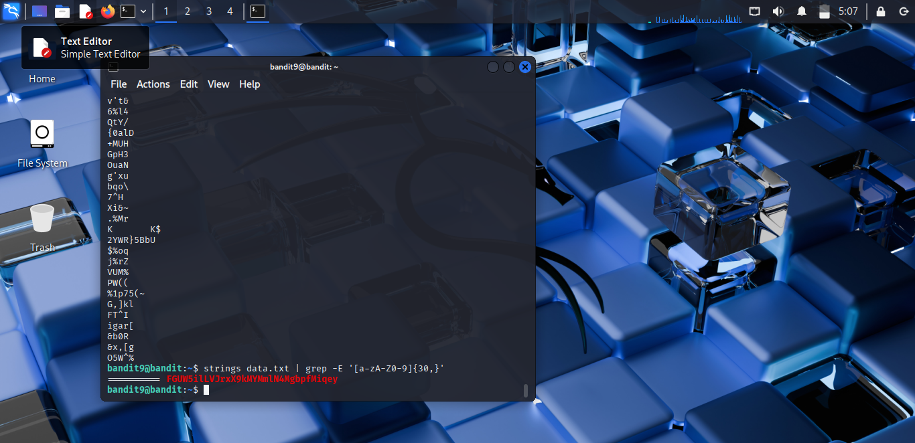

# **Bandit-11**

Decode a base64-encoded file to reveal the password.

strings data.txt | grep -Eo '([A-Za-z0-9+/]{30,}={0,2})' | while read s; do echo "$s" | base64 -d 2>/dev/null && echo; done

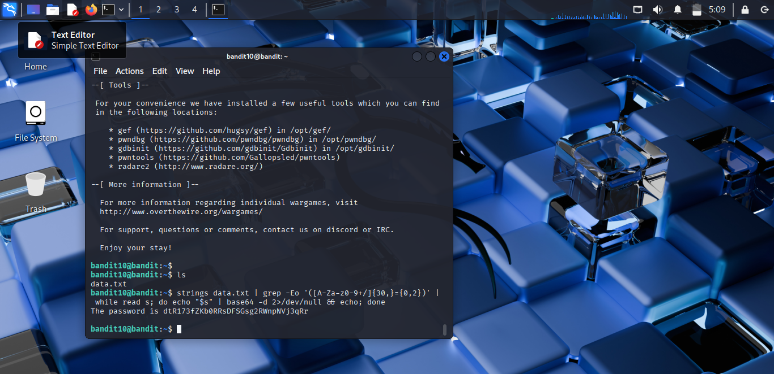

# **Bandit-12**

Decrypt a ROT13-encoded file using tr

cat data.txt | tr 'A-Za-z' 'N-ZA-Mn-za-m'

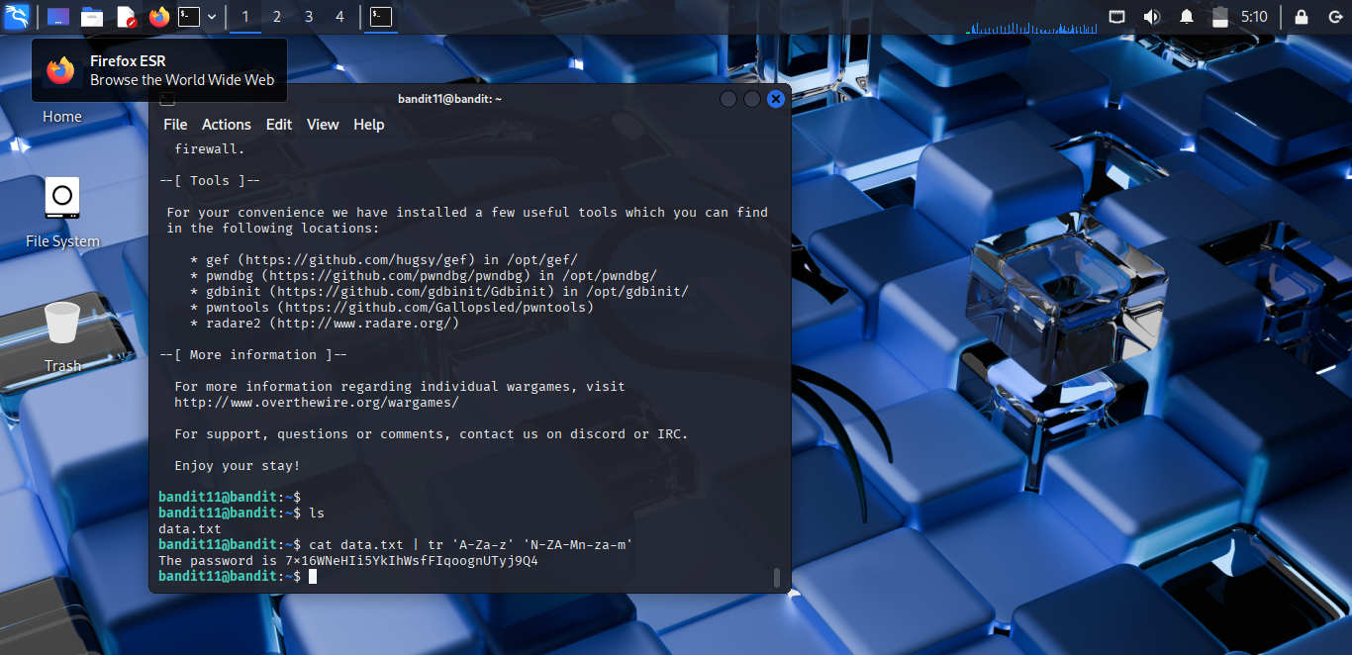

7x16WNeHIi5YkIhWsfFIqoognUTyj9Q4